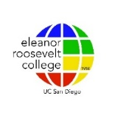
ERC Global Service Certification Documentation Form

Due the last day of May

Name: ___________________________ PID: ___________________________
E-mail: ___________________________ Date: ___________________________
Documentation - List the Nine Activities You completed (Global Understanding, Cultural Competence, Social Responsibility/Advocacy):
Gold – 10 hours or more of knowledge acquisition, skill-building, training, or service on a one-time, series or continuation basis.
Blue – Less than 10 hours of knowledge acquisition, skill-building, training, or service on a one-time basis only.

 | Name of Activity/Event | Date | Hours
E
R
C
G
L
O
B
A
L

